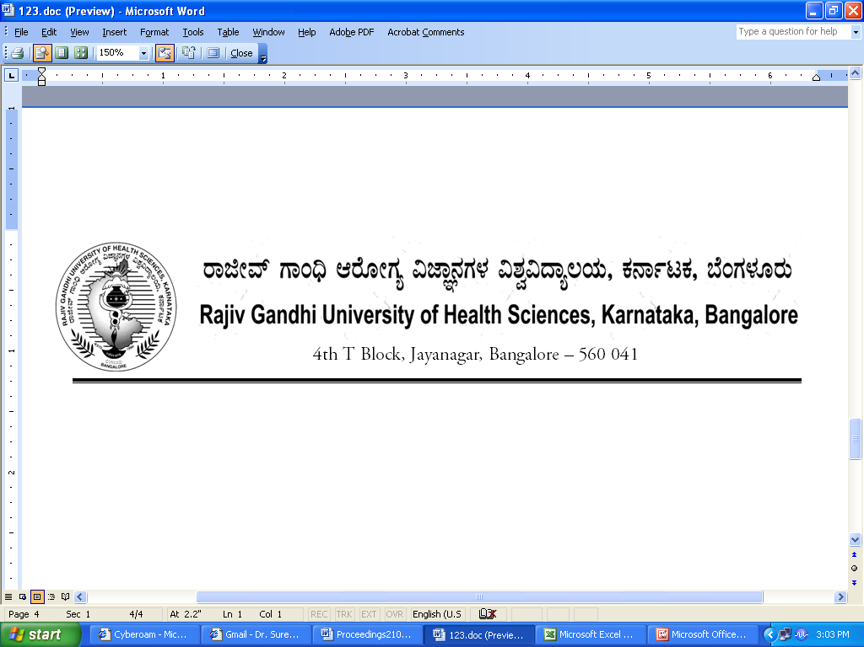
Reg(E)Exam/UG/PG/AHS/Aug/Sept- 2018 Date: 20/07/2018

To,

The Director / Dean / Principals of
All Allied Health Science Colleges (UG & PG)
Affiliated to RGUHS.

Sir / Madam,

Sub : | Providing the number of students appearing for Allied Health Science courses (UG & PG) Practical examination August/September- 2018.

With reference to the above, you are hereby informed to send the number of students appearing for August/September- 2018 Allied Health Sciences (UG & PG) practical examination same may be forwarded in the following proforma on or before 04/08/2018 addressed to Registrar (Evaluation) without fail to speed up the examination process.
Allied Health Sciences (UG & PG)

Name of the Student | Register No | Name of the Course  (Practical)

Thanking you,

Yours faithfully,

Sd/-
Registrar [Evaluation]

